**MAIN GUI:**

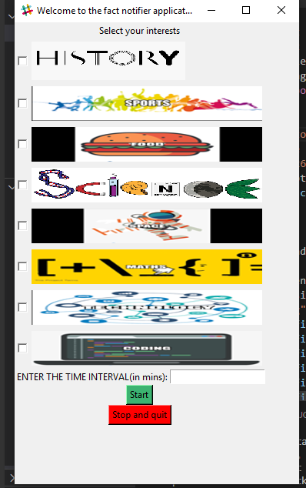

**User Interests:**

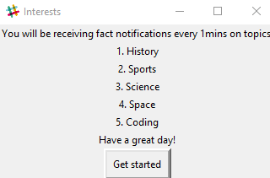

**Informing user about notifications and how to stop them:**

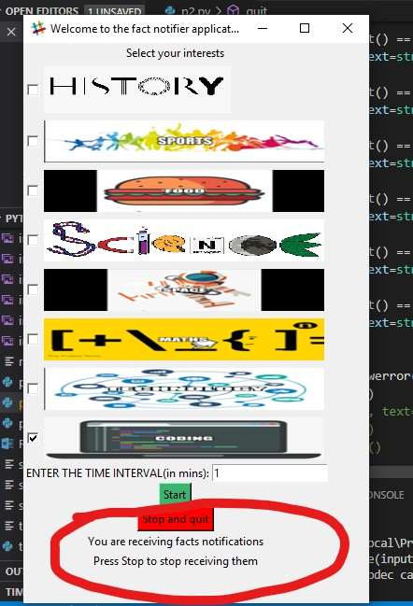

**Showing user error message that he hasn’t selected any interest:**

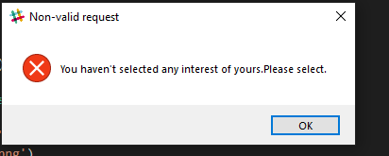

**Showing user the message that he has entered non valid time interval:**

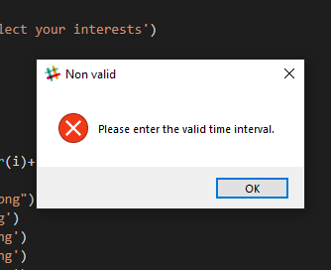

**RESULT 1: (Notifications)**

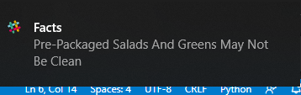

**RESULT 2: (Notifications)**

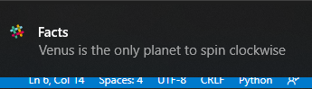

**RESULT 3: (Notifications)**

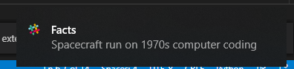

**RESULT 4: (Notifications)**

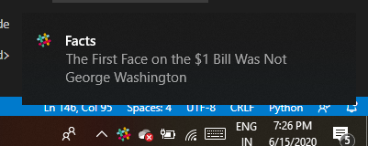

**RESULT 5: (Notifications)**

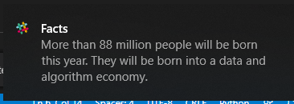

**RESULT 6: (Notifications)**



**RESULT 7: (Notifications)**

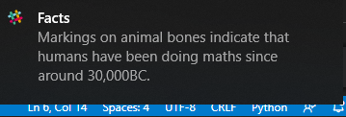

**RESULT 8: (Notifications)**

